Facial Recognition Algorithm – Performance Evaluation Raspberry Pi 4 vs. 5
Franco Sandoval, Martin Navarrete, Kevyn Santos, Daniel Alvarez, Mohamed El-Hadedy
Email: {fsdoval, mnavarrete1, kevynsantos, daalvarez, meady} @cpp.edu
ECE Department, California State Polytechnic University Pomona, College of Engineering

Abstract— This project evaluates the performance of real-time facial recognition on two different generations of Raspberry Pi computers. The computers are the Raspberry Pi 4 Model B (8 GB) and the Raspberry Pi 5 (8 GB). With the use of the Pi camera module and a Python application built with OpenCV and the “face_recognition” library, video and performance face detection testing and recognition were captured live entirely on-device. Experiments were conducted at two resolutions, 640x480 and 1280x720, while varying the number of faces in view from 0 to 4. This emulates different real-world usage scenarios. For each configuration, time-series data for CPU utilization, CPU temperature, memory usage, and frames per second (FPS) were collected.

Introduction
Over the last two decades, security systems have dramatically increased in both importance and usage, leading to various innovations, such as biometrics-based security and facial recognition software. Innovations in other fields, such as artificial intelligence (AI) that require large amounts of power currently necessitate that other processes within a given system minimize power consumption, to maximize the efficiency of the entire system. Integrating AI with security programs, now more than ever is in high demand, so we must seek to develop new designs for this purpose, while simultaneously optimizing and discerning between existing systems.
When considering low power operation, accessibility, open-source support, and computing power, the Raspberry Pi is a strong candidate for testing. The most recent edition of the Raspberry Pi (RP) series is the RP-5, which has a 2.4GHz quad core 64-bit CPU, and uses RISC architecture. With its ease of implementation and integration, the RP-5 is an excellent starting point for testing. Although we will be evaluating the entirety of a device, the largest load will be put on the CPU, hence our highlighting the specifications of the CPU here. Testing the RP-5 alone would not provide sufficient results, as there would be no standard to compare it to. For that reason, we are seeking to test the previous device in the RP series, the RP-4. The RP-4 also has a quad core 64-bit CPU, but the clock rate on the RP-4 is 1.8 GHz. Additionally, since the Raspberry Pi 4 also uses a RISC architecture, we can make a more direct comparison between the two models. Both devices used 8 GB of RAM; we made that a control variable to limit the differences in our results to the CPU and the architecture.
In this paper, we will upload a facial recognition program compiled in Python to both the RP-5 and RP-4 and compare their performance in running the program with constant visual input. We will compare the frames per second that each Pi can capture, analyze, and display, as well as the temperature of each CPU while running the program, and the utilization of the CPU and memory space as percentages. Throughout this paper, we will be answering the following questions: How does the number of faces in the frame affect system load and performance on each Pi? Does the Pi 4 or Pi 5 handle thermal load better under sustained facial recognition workloads? How efficient is each Pi using its 8GB of RAM for this task? Under identical conditions, which Pi provides the better “performance per resource used”?
Throughout this paper, we compare the Raspberry Pi 4 and Raspberry Pi 5 by examining how face count influences performance, how each device handles thermal stress, how efficiently each uses its 8 GB of RAM, and which model ultimately offers better performance relative to resource usage.

II. Related Work
Facial recognition on low-cost embedded platforms such as the Raspberry Pi is not new. However, it can be said that it has been widely explored in recent years. One study from Aboluhom et al. [1] investigates real-time facial recognition using multitask learning on a Raspberry Pi. Their results highlight both the feasibility of on-device learning and the sensitivity of performance to model size.
Another paper that is heavily related to the project stated here is from the research project “Low-Resource Hardware Performance Analysis for Real-Time Facial Recognition” by Luis et al. [2] This article compares three devices and how well each device handles real-time face recognition. The devices used are a Raspberry Pi 4, a Raspberry Pi 5 and a desktop computer. The main goal of the experiment is to understand CPU usage, RAM consumption, temperature, and latency when there are various facial recognition models on low-resource hardware. The setup is also very similar to that of these papers in that it takes place in an office setting in which there are four people who are in a fixed area on screen. However, the difference between the experiments is that for this paper, the four test subjects are standing still, while Luis’s experiment has the test subjects walking on a fixed path. Another difference is that the related project only has two of the four people that are actually enrolled in the face-recognition database. This paper had all four people enrolled and trained with the facial recognition database model. The last similarity between both experiments is one of the resolutions that was tested. In both cases, the resolution of 1280x720 was used. Nevertheless, the experiment in this paper also utilizes the resolution 640x480 to test the facial-recognition effect on the Raspberry Pi’s under different environments. Please refer to the experiments description and results in the following sections.

III. Facial recognition script utilized
The program itself consists of three main files: a script for image capture, a script for model training, and a script for facial recognition,
To utilize the image capture script, we attached a camera to both devices, the Pi Camera 2. That script creates a folder in the Pi directory for each person the model is being trained with. The Pi Camera can record images in 1280 by 720 pixels, 640 by 480 pixels, or any resolution the user wishes. Then it captures the RGB values of each pixel. Upon taking about four pictures of each person, one from the front, one from each side, and one with the head tilted upwards slightly, the Pi will have enough data to learn from and eventually recognize that person later. This code will create a folder that saves all those images to later train the model.
When using the model training script, it goes through all the folders, one by one, and then each of the folders’ images to train a model. This “training” turns the images into encodings, or unique values, that are used when recognizing faces. This code also creates bounding boxes with the names of the faces. The saved encodings are used when running the facial recognition script.
In the facial recognition script, we first load all the face encodings into an array. The camera is then initialized, and frames are constantly processed. The encodings are then compared to the current frame so that faces can be recognized. Once recognized, a box will surround the familiar face. Lastly, in this code, we calculate the frames per second and log the values to ensure accuracy.

IV. Experiment Description
As stated in the abstract, the experiment was designed to compare the performance of real-time facial recognition on a Raspberry Pi 4 Model B (8 GB) and a Raspberry Pi 5 (8 GB) under a set of controlled conditions. These conditions were the utilization of the same Pi Camera Module V2 (8 MP, 1080 capable) and the use of the same Python application based on OpenCV for frame acquisition, resizing, and visualization with the use of the face_recognition library for face detection and identification.
The experiment captured frames from the camera, which then were converted to the required color space. Then, the frames were passed to the face-recognition pipeline, which overlaid bounding boxes and name labels for any recognized faces from the dataset. Please refer to the figures below.
In addition, to simulate different real-world scenarios, we varied two main factors: camera resolution and the number of faces present in the frame. For each of the Pi’s, tests were performed at 640x480 and 1280x720 resolutions. For each of the resolutions tested, data with 0, 1, 2, 3, and 4 faces positioned withing the field of view were collected.
Lastly, for every device-resolution-face-count combination, the system was running continuously while time-series performance data was recorded. The following results and datasets can be found in the figures below. As shown, the metrics of interest were CPU utilization (%), CPU temperature (degrees Celsius), memory usage, and frames per second (FPS). The resulting datasets enabled a direct comparison between the Raspberry Pi 4 and the Raspberry Pi 5 in terms of resource usage, and thermal behavior across all tested scenarios.
(a) Image of the person 1
(b) Image of the person 2
(c) Image of the person 3

(d) Image of the person 4
Fig. 1. Images used to train the Facial-recognition Model

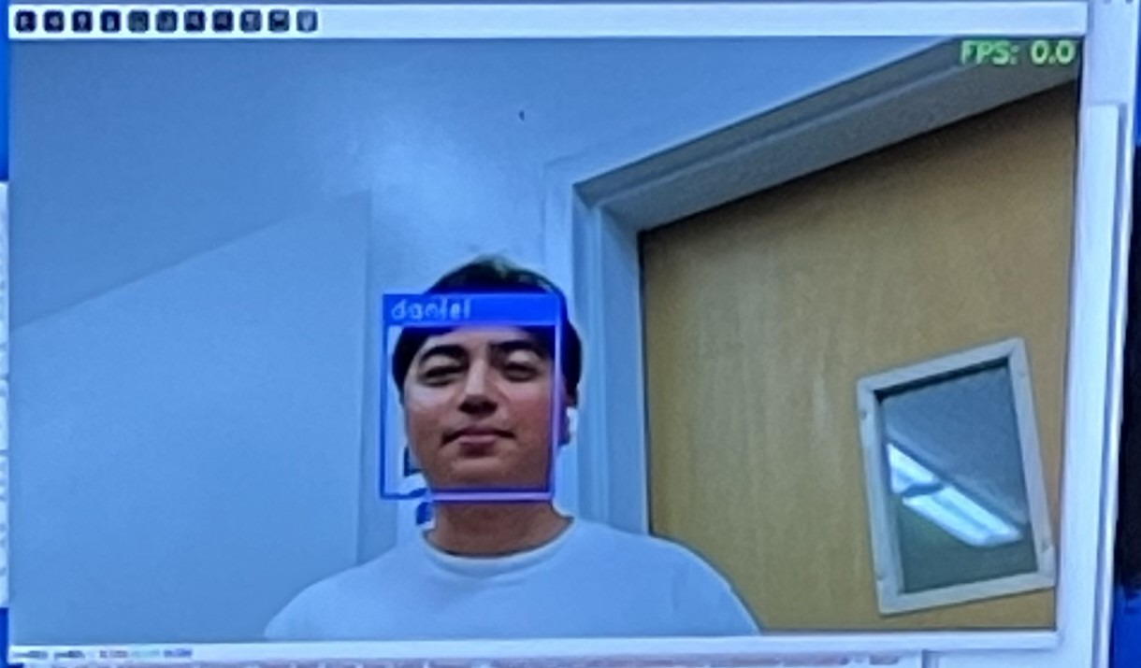(a) facial-recognition 1 person test

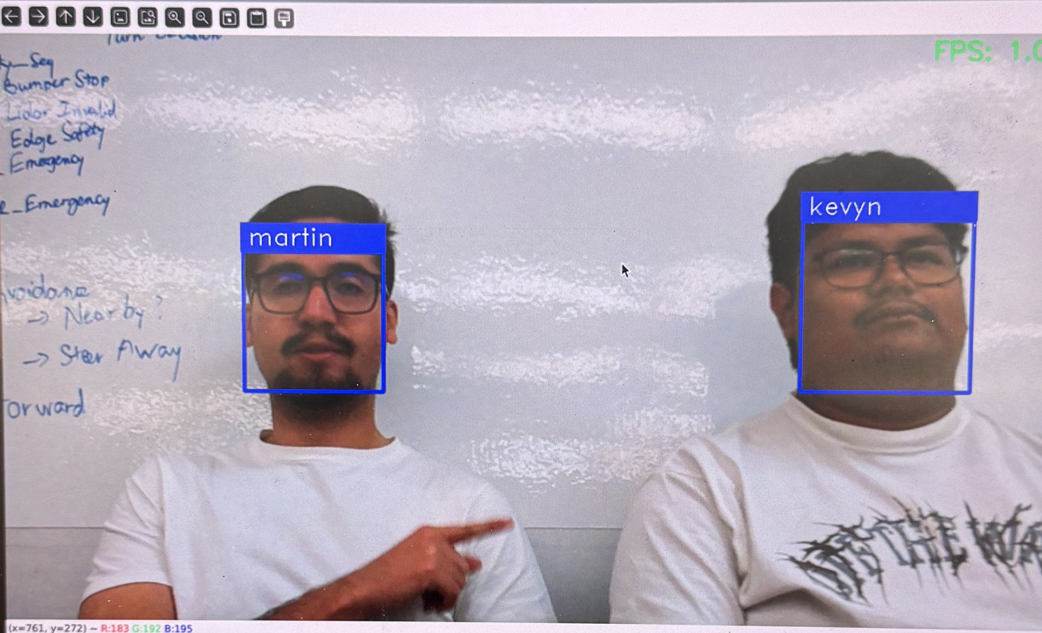(b) facial-recognition 2-person test

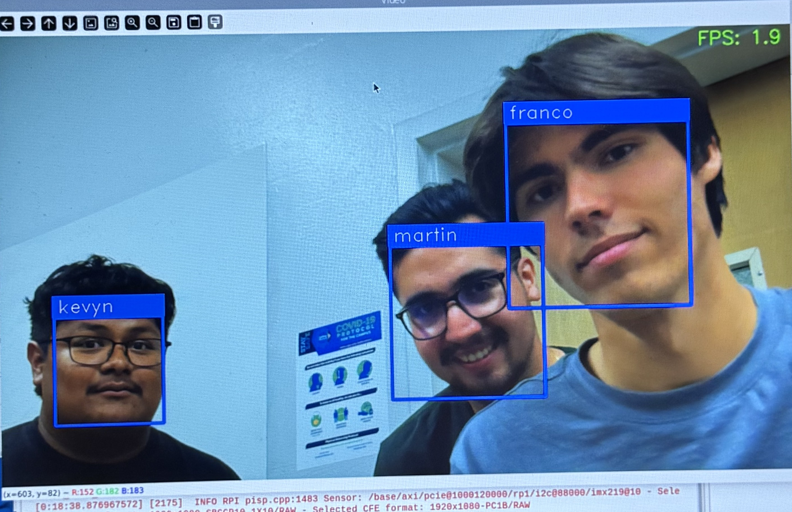(c) facial-recognition 3-person test
Fig. 2. Testing facial-recognition detection using dataset collected

V. Results
The following section presents the results of the experiments. As stated previously, the factors analyzed are CPU utilization, CPU temperature, RAM usage, and FPS comparison between the two Raspberry Pi’s.

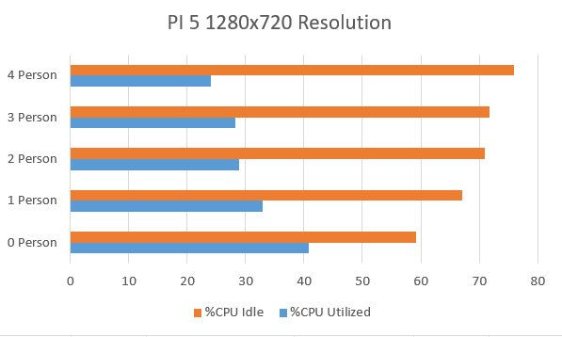(a) Pi 5 CPU % Utilization 1280x720 Resolution among 4 persons

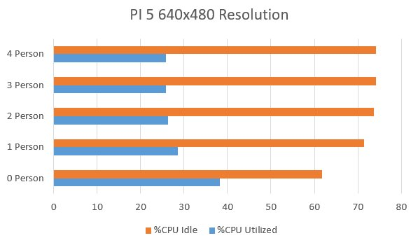(b) Pi 5 CPU % Utilization 640x480 Resolution among 4 persons

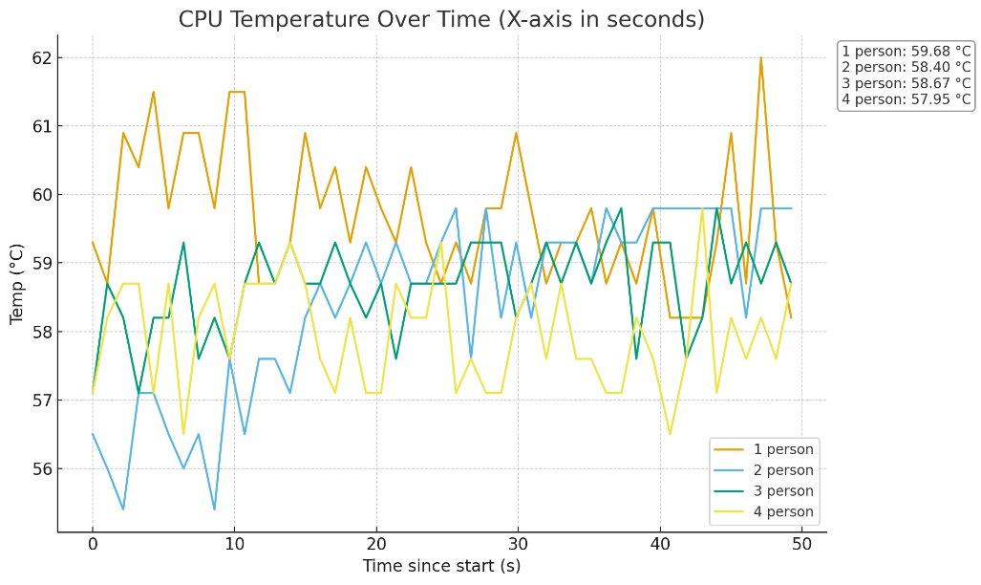(c) Pi 5 CPU Temperature 1280x720 Resolution
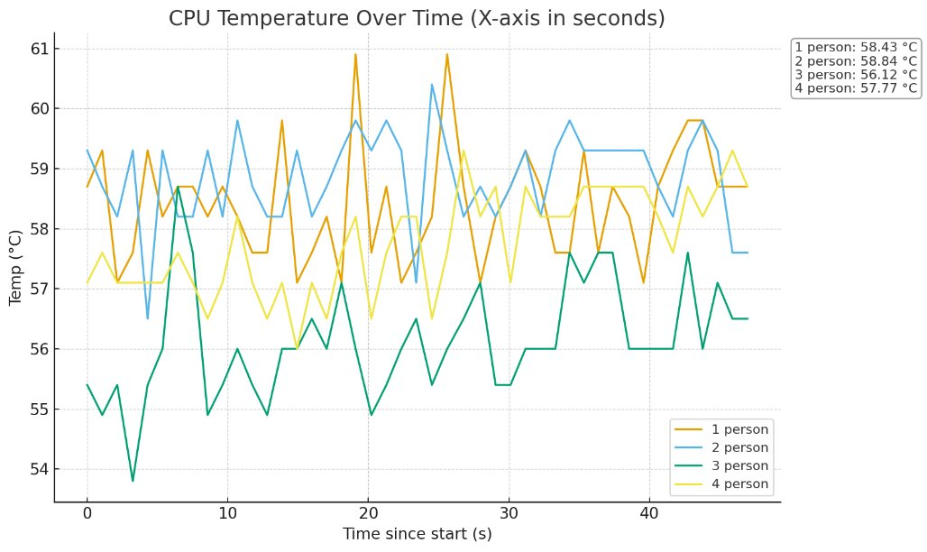(d) Pi 5 CPU Temperature 640x480 Resolution

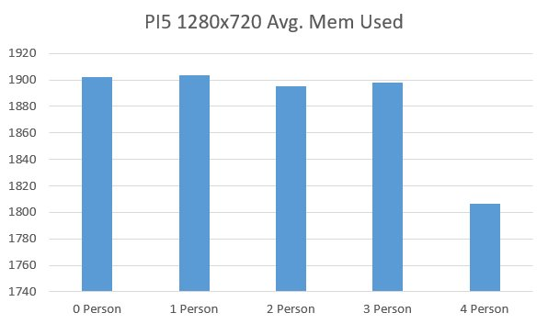(e) Pi 5 RAM usage 1280x720 Resolution

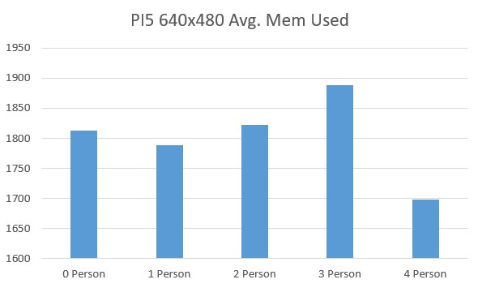(f) Pi 5 RAM usage 640x480 Resolution

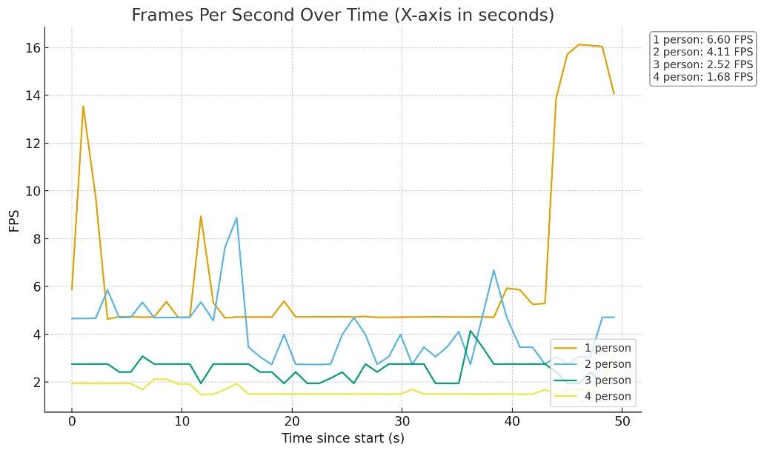(g) Pi 5 FPS Comparison 1280x720 Resolution

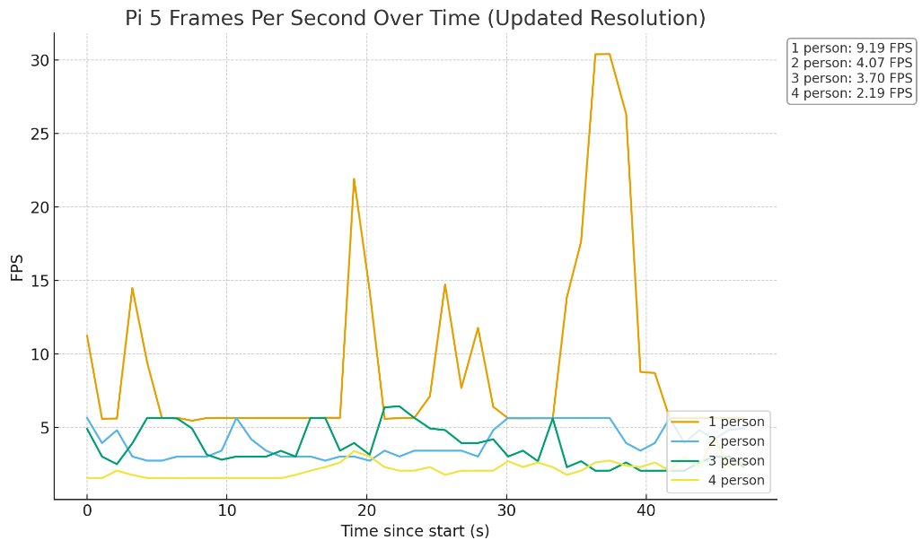(h) Pi 5 FPS Comparison 640x480 Resolution
Fig. 3. Results of the experiment using the Raspberry Pi 5 at two different resolutions

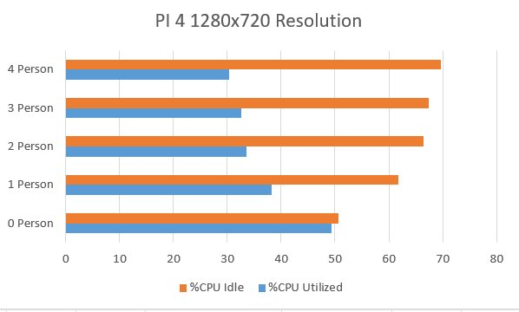(a) Pi 4 % CPU Utilization 1280x720 Resolution among 4 persons

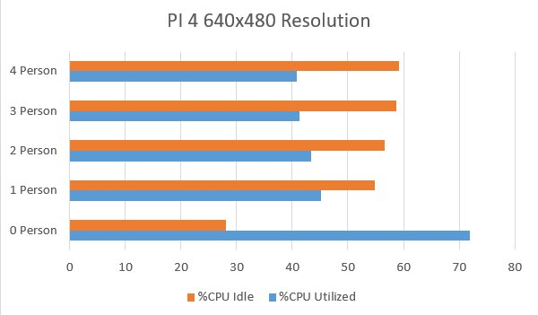(b) Pi 4 % CPU Utilization 640x480 Resolution among 4 persons

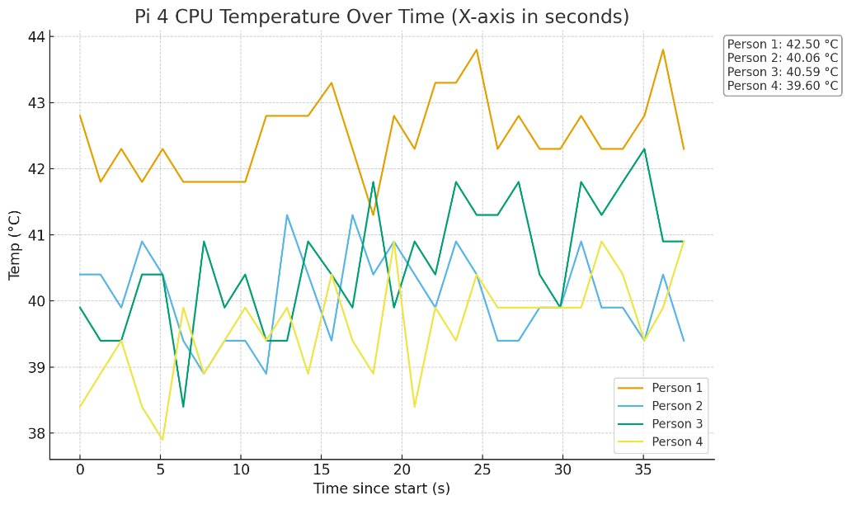(c) Pi 4 CPU Temperature 1280x720 Resolution

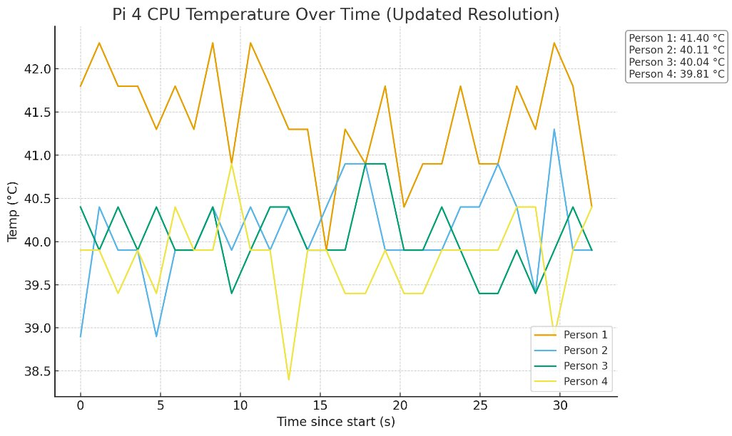(d) Pi 4 CPU Temperature 640x480 Resolution

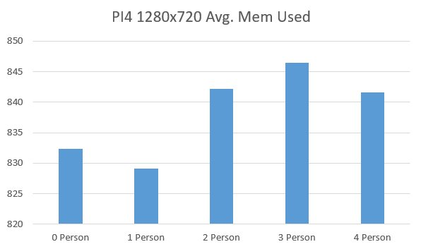(e) Pi 4 RAM usage 1280x720 Resolution

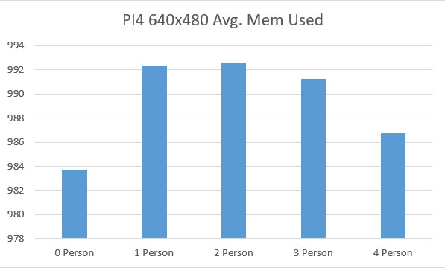(f) Pi 4 RAM usage 640x480 Resolution

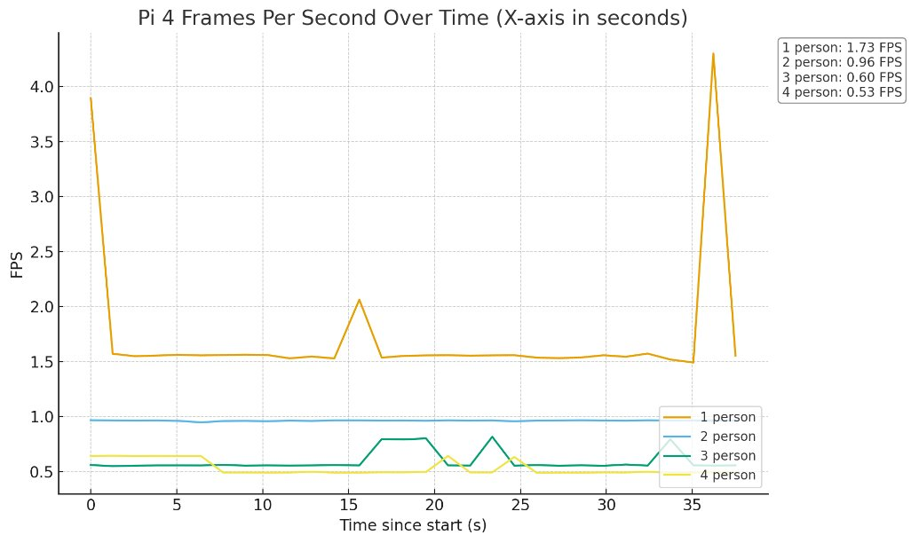(g) Pi 4 FPS Comparison 1280x720 Resolution

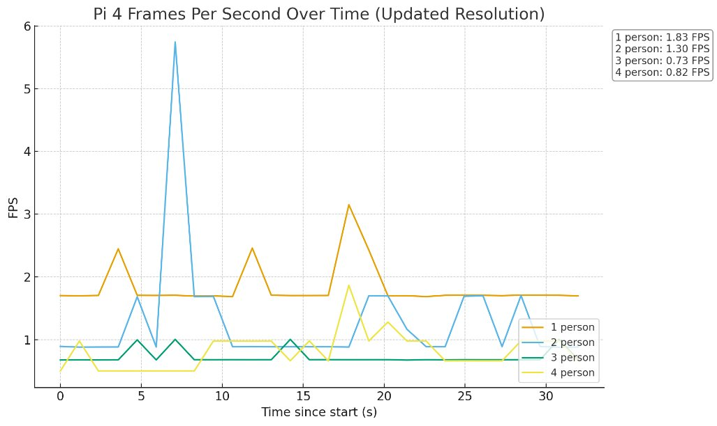(h) Pi 4 FPS Comparison 640x480 Resolution

Conclusion
The work of this experiment was used to compare real-time facial recognition performance on the Raspberry Pi 4 Model B (8 GB) and the Raspberry Pi 5 (8 GB) using a common software stack. In this experiment, OpenCV and the face_recognition library were used. Both platforms were tested with the same two different resolutions, while multiple faces were introduced on screen from 0 to 4 people. During this process, CPU utilization, temperature, memory usage, and frames per second (FPS) were collected.
Regarding the first research question (RQ1), “effect of number of faces on system load and performance), the results show that increasing the number of faces increases the CPU utilization and reduces the idle headroom on both platforms. In addition, the impact on FPS is more noticeable at 1280x720. For this resolution, the Pi 4 reaches a higher CPU usage and maintains lower FPS.

The second research question (RQ2), “Thermal Behavior”, illustrates that the Pi 5 operates at a greater temperature than the Pi 4 at both resolutions. However, both remain below typical throttle. The results discovered in this experiment align closely to the findings in “Low-Resource Hardware Performance Analysis for Real-Time Facial Recognition” by Luis et al. [2].

For the third research question (RQ3), “RAM efficiency”, there appears to be a distinction between both platforms. The Pi 4 typically uses under 1 GB, while the Pi 5 uses an average of 1.5-2 GB depending on the resolution and number of faces within frame. From the results gathered, it can be said that memory capacity and utilization are not limiting factors for the workload.

Finally, for the fourth research question (RQ4) “performance per resource used), the Pi 5 consistently delivers higher FPS than the Pi 4 throughout the same CPU utilization range. This result suggests better performance for the Pi 5 than the older platform, the Pi 4. However, if the temperature is considered then, it can be said that the Raspberry Pi 4 is more thermally efficient, although it produces lower FPS. In the end, for experiments that prioritize throughput and can provide additional cooling, the Pi 5 would be the better choice. Nevertheless, the Pi 4 still remains an adequate alternative for lower-resolution facial recognition tasks.

References
[1] M. Bansal, “Face Recognition Implementation on Raspberrypi Using Opencv and Python,” International Journal of Computer Engineering and Technology, vol. 10, no. 3, pp. 141–144, 2019. [Online]. Available: https://ssrn.com/abstract=3557027. Accessed: Dec. 1, 2025.

[2] E. A. P. Luis, F. Perez-Tellez, and D. Pinto, “Low-Resource Hardware Performance Analysis for Real-Time Facial Recognition,” Research in Computing Science, vol. 154, no. 5, pp. 35–46, 2025. [Online]. Available: https://www.rcs.cic.ipn.mx/2025_154_5/Low-Resource%20Hardware%20Performance%20Analysis%20for%20Real-Time%20Facial%20Recognition.pdf. Accessed: Dec. 1, 2025.

[3] Raspberry Pi Ltd, “Raspberry Pi 4 Model B specifications,” Raspberry Pi, 2025. [Online]. Available: https://www.raspberrypi.com/products/raspberry-pi-4-model-b/specifications/. Accessed: Dec. 1, 2025.

[4] Raspberry Pi Ltd, “Raspberry Pi 5,” Raspberry Pi, 2025. [Online]. Available: https://www.raspberrypi.com/products/raspberry-pi-5/. Accessed: Dec. 1, 2025.

[5] Jaryd, “Face Recognition With Raspberry Pi and OpenCV,” Core Electronics Guides, Oct. 20, 2024. [Online]. Available: https://core-electronics.com.au/guides/raspberry-pi/face-recognition-with-raspberry-pi-and-opencv/. Accessed: Dec. 1, 2025.

[6] Raspberry Pi Ltd, “Raspberry Pi Camera Module v2,” Raspberry Pi, 2025. [Online]. Available: https://www.raspberrypi.com/products/camera-module-v2/. Accessed: Dec. 1, 2025.

Acknowledgment
An acknowledgement statement, if applicable, goes here before the references section. This section head is not numbered and is always singular, i.e., never “Acknowledgements”.

